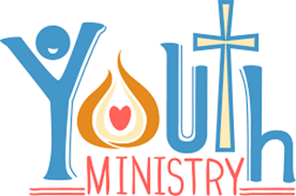
Calendar Senior High
August 2019 | September | October
8/4-11  Mission trip to son spot. Senior high! |  | 10/3 24/7 6-8:30pm  Dinner, worship music, God’s word, and Fun!! Bring a friend!
8/21 Baptisms Wednesday, 7:00pm Off campus. | 9/5 24/7 6-8:30pm  Dinner, worship music, God’s word, and Fun!! Bring a friend! | 10/10 24/7 6-8:30pm  Dinner, worship music, God’s word, and Fun!! Bring a friend!
8/22 First 24/7 6-8:30pm  Dinner, worship music, God’s word, and Fun!! Bring a friend! | 9/8 24 Soulz! KICKOFF PARTY! 530-730  Both middle and senior high invited! | 10/13 Harvest Party!  Youth needed to volunteer! From 5:30-7:30pm
8/23 Back to school Prayer and Worship Night. 6-7 pm pizza in Fellowship Hall, 7 pm prayer and worship starts in Sanctuary. | 9/12 24/7 6-8:30pm  Dinner, worship music, God’s word, and Fun!! Bring a friend! | 10/17 Third Thursday  Any youth from 8th grade and above. Dinner, games, music and more!
8/25 Church Picnic  Susquehanna state park. All ages invited! | 9/19 Third Thursday  Any youth from 8th grade and above. Dinner, games, music and more! | 10/24 24/7 6-8:30pm  Dinner, worship music, God’s word, and Fun!! Bring a friend!
8/29 24/7 6-8:30pm  Dinner, worship music, God’s word, and Fun!! Bring a friend! | 9/26 24/7 6-8:30pm  Dinner, worship music, God’s word, and Fun!! Bring a friend! | 10/25-27 YOUTH RETREAT!! North East, MD  Senior High- North Bay  Middle High- Sandy Hill
HUM- August 16 | HUM – September 7 | 10/31 No 24/7

